Курсовой Проект

По Дисциплине

Электротехника И Электроника

Макарова Евгения

Вариант №16

А-8-99

25.04.2001
Исходная схема и данные.
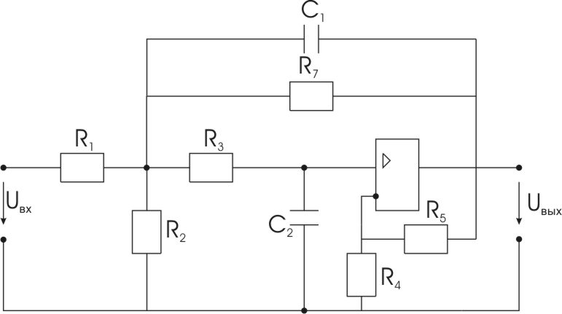

R₁ = 30 кОм; R₂ = 50 кОм; R₃ = 15 кОм; R₄ = 6 кОм; R₅ = 2 кОм; R₇ = 10 кОм;
C₁ = 26.3 нф; C₁ = 3.56 нф;

Часть I. Анализ частотных характеристик цепи.

1.1. Расчет передаточной функции Н(р) = Н(jw) при идеальном ОУ.
Расчетная схема
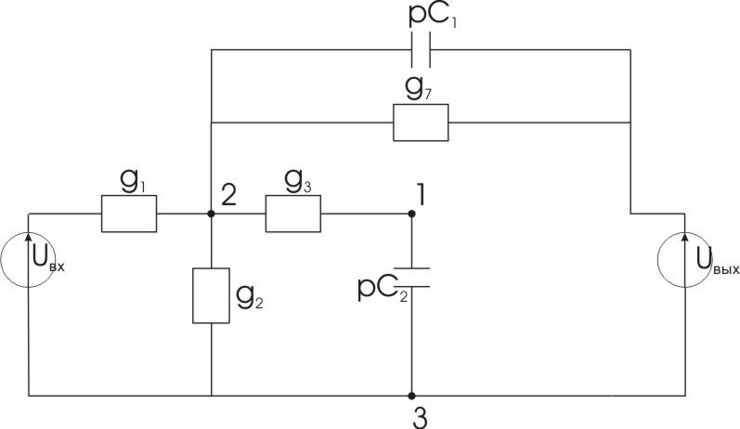
U_{вх} = е; U_{вых} = k₀⋅ϕ₁
k₀ = 1 + R₅/R₄ = 1 + 2/6 = 1.3333333
g₁ = 1/R₁ = 0.0333⋅10⁻³ см; g₂ = 1/R₂ = 0.2⋅10⁻³ см; g₃ = 1/R₃ = 0.06667⋅10⁻³ см;
g₇ = 1/R₇ = 0.1⋅10⁻³ см;

Получим систему узловых уравнений. Имеем схему с 3 узлами, ϕ₃ = 0 В.
$$\begin{aligned}\left\{ϕ_{1}(g_{3}+{\text{pC}}_{2})+ϕ_{2}(−g_{3})=0 | \right.\end{aligned}$$
$$\begin{aligned}\left\{ϕ_{1}(g_{3}+{\text{pC}}_{2})+ϕ_{2}(−g_{3})=0 | \right.\end{aligned}$$
Найдем Δ^{(у)} и Δ⁽¹⁾
$Δ^{(y)}=\left|\begin{matrix}g_{3}+{\text{pC}}_{2} & −g_{3} \\ −g_{3}−k_{0}g_{7}−k_{0}{\text{pC}}_{1} & g_{1}+g_{2}+g_{3}+g_{7}+{\text{pC}}_{1}\end{matrix}\right|=$ g₃(g₁ + g₂) + g₃g₇(1 - k₀) +
+pC₂(g₁+g₂+g₃+g₇) + pC₁g₃(1 – k₀) + p₂C₁C₂
$Δ^{(1)}=\left|\begin{matrix}0 & −g_{3} \\ {\text{eg}}_{1} & g_{1}+g_{2}+g_{3}+g_{7}+{\text{pC}}_{1}\end{matrix}\right|={\text{eg}}_{1}g_{3}$; ϕ₁(p) = Δ⁽¹⁾/Δ^{(y)};
$$\begin{aligned}H(p)=\frac{k_{0}ϕ_{1}(p)}{e}=\frac{k_{0}Δ^{(1)}}{{eΔ}^{(y)}}=\frac{\frac{k_{0}g_{1}g_{3}}{C_{1}C_{2}}}{\frac{g_{3}(g_{1}+g_{2})+g_{3}g_{7}(1−k_{0})}{C_{1}C_{2}}+p\left[\frac{g_{1}+g_{2}+g_{3}+g_{7}}{C_{1}}+\frac{g_{3}(1−k_{0})}{C_{2}}\right]+p^{2}}= \\ \frac{b_{0}+b_{1}p+b_{2}p^{2}}{a_{0}+a_{1}p+p^{2}}\end{aligned}$$
Найдем коэффициенты:
$a_{0}=\frac{g_{3}(g_{1}+g_{2})+g_{3}g_{7}(1−k_{0})}{C_{1}C_{2}}=\frac{{\text{10}}^{−3}(0\text{.}\text{066}(0\text{.}\text{033}+0\text{.}2)+0\text{.}\text{066}⋅0\text{.}1(1−1\text{.}\text{333}))}{\text{26}\text{.}3⋅3\text{.}\text{56}⋅{\text{10}}^{−\text{12}}}=1\text{.}\text{42406}⋅{\text{10}}^{8} 1/{c^{2}}$Резонансная частота:
ω₀ = $\sqrt{a_{0}}$= 1.1933⋅10⁴ 1/c; f₀ = ω₀/2π = 1.8993⋅10³ 1/c = 1.8993 кГц.
$$\begin{aligned}a_{1}=\frac{g_{1}+g_{2}+g_{3}+g_{7}}{C_{1}}+\frac{g_{3}(1−k_{0})}{C_{2}}=\frac{{\text{10}}^{−3}(0\text{.}\text{033}+0\text{.}2+0\text{.}\text{066}+0\text{.}1)}{\text{26}\text{.}3⋅{\text{10}}^{−6}}+\frac{(1−1\text{.}\text{333})⋅0\text{.}\text{066}⋅{\text{10}}^{−3}}{3\text{.}\text{56}⋅{\text{10}}^{−6}}= \\ 0\text{.}\text{89667}⋅{\text{10}}^{4} 1/c\end{aligned}$$
Добротность схемы: Q = ω₀/a₁ = 1.3308;
b₀ = $\frac{g_{1}g_{3}k_{0}}{C_{1}C_{2}}=$0.31646⋅10⁸ 1/c²; b₁ = 0 1/c; b₂ = 0;
Получаем:
$H(p)=\frac{0\text{.}\text{31646}⋅{\text{10}}^{8}}{1\text{.}\text{42406}⋅{\text{10}}^{8}+0\text{.}\text{89667}⋅{\text{10}}^{4}p+p^{2}}$ заменяем p = jω:
$$H(jω)=\frac{0\text{.}\text{31646}⋅{\text{10}}^{8}}{1\text{.}\text{42406}⋅{\text{10}}^{8}+j⋅ω⋅0\text{.}\text{89667}⋅{\text{10}}^{4}−ω^{2}}$$

Найдем выражения для АЧХ – Н(ω) и ФЧХ - ϕ(ω).
Выражение для АЧХ:
$$H(ω)=\frac{0\text{.}\text{31646}⋅{\text{10}}^{8}}{\sqrt{{\left(1\text{.}\text{42406}⋅{\text{10}}^{8}−ω^{2}\right)}^{2}+{\left(ω⋅0\text{.}\text{89667}⋅{\text{10}}^{4}\right)}^{2}}}$$
$\begin{aligned}\left.H(0)=0\text{.}\text{2222} | \right\}\end{aligned}$ ⇒ низкочастотный фильтр (ФНЧ)

Выражение для ФЧХ:
ω < ω₀ $ϕ(ω)=−\text{arctg}\left[\frac{ω⋅0\text{.}\text{896667}⋅{\text{10}}^{4}}{1\text{.}\text{42406}⋅{\text{10}}^{8}−ω^{2}}\right]$; ϕ(0) = 0°
ω > ω₀ $ϕ(ω)=−\text{180}\text{°+}\text{arctg}\left[\frac{ω⋅0\text{.}\text{896667}⋅{\text{10}}^{4}}{ω^{2}−1\text{.}\text{42406}⋅{\text{10}}^{8}}\right]$; ϕ(ω₀) = -90°; ϕ(∞) = -180°;

1.2. Построение зависимостей АЧХ и ФЧХ.
Интервал [0; 2₀]  [0; 24000 1/c]
ω,10⁴ | 0 | 0.2 | 0.4 | 0.6 | 0.8 | 1.0 | 1.19
H | 0.2222 | 0.2268 | 0.2408 | 0.2654 | 0.2978 | 0.3191 | 0.2958
ϕ° | 0° | -7.4° | -15.8° | -26.8° | -42.5° | -64.7° | -90°
ω,10⁴ | 1.4 | 1.6 | 1.8 | 2.0 | 2.2 | 2.4 | 1.4
H | 0.2318 | 0.1729 | 0.1303 | 0.1008 | 0.08 | 0.065 | 0.2318
ϕ° | -113.1° | -128.4° | -138.4° | -145.2° | -150° | -153.6° | -113.1°
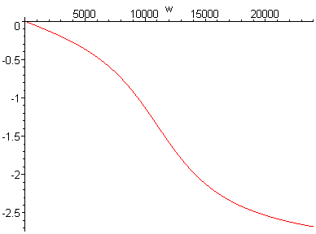
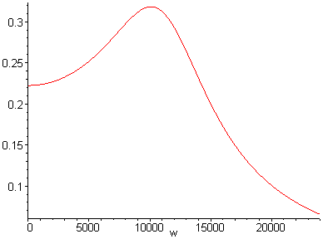

1.3. Эквивалентная схема для реального ОУ.
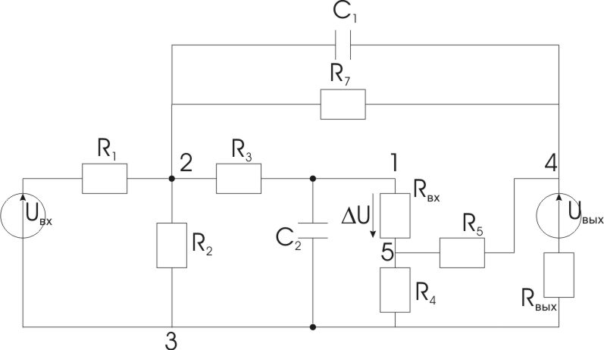
ΔU = ϕ₁ - ϕ₅; k = 250; R_{вх} = 50 кОм; R_{вых} = 0.2 кОм; U_{вых} = k⋅ΔU;
Имеем схему с 5-ю узлами.

Часть II. Анализ временных характеристик цепи.
2.1. Расчет переходной h(t) и импульсной h_{δ}(t) характеристик цепи для идеального ОУ.
а) С использованием уравнений состояния.
Расчетная схеам:
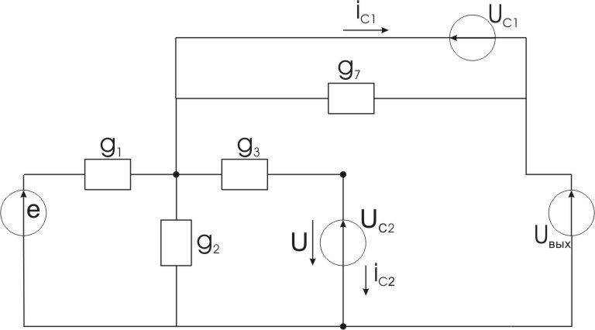
Заменяем емкости С₁ и С₂ на источники эдс U_{с1} и U_{c2}.
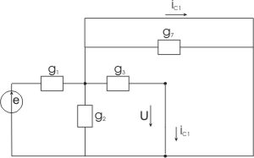
Найдем выражения для i_{c1}, i_{c2}, U.
Используем принцип суперпозиции.

1. e ≠ 0, U_{c1} = U_{c2} = U_{вых} = 0
i_{C1} = e⋅g₁
i_{C2} = 0
U = 0

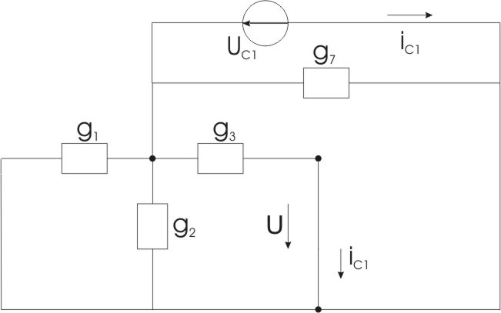
2. U_{C1} ≠ 0, e = U_{C2} = U_{вых} = 0
i_{C1} = U_{C1}(-g₁ – g₂ – g₃ – g₇)
i_{C2} = U_{C1}⋅g₃
U = 0

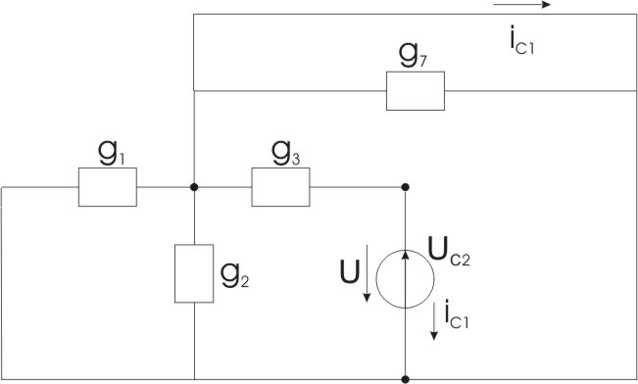
3. U_{C2} ≠ 0, e = U_{C1} = U_{вых} = 0
i_{C1} = U_{C2}⋅g₃
i_{C2} = U_{C1}⋅(-g₃)
U = U_{C2}

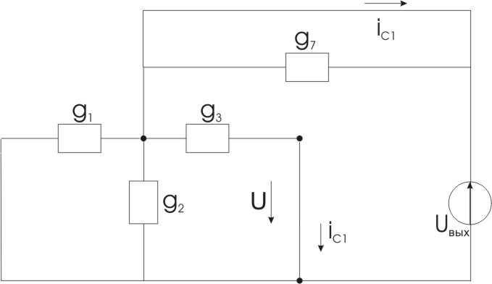
4. U_{вых} ≠ 0, e = U_{C1} = U_{C2} = 0
i_{C1} = U_{вых}⋅(-g₁ – g₂ – g₃)
i_{C2} = U_{вых}⋅g₃
U = 0

Получаем:
$$\begin{aligned}\left\{i_{C1}=U_{C1}(−g_{1}−g_{2}−g_{3}−g_{7})+U_{C_{2}}g_{3}+U_{\text{вых}}(−g_{1}−g_{2}−g_{3})+{\text{eg}}_{1} | \right.\end{aligned}$$
U = U_{C2}; U_{вых} = k₀U=k₀U_{C2};
$$\begin{aligned}\left\{i_{C1}=U_{C1}(−g_{1}−g_{2}−g_{3}−g_{7})+U_{C_{2}}(g_{3}[1−k_{0}]−g_{1}k_{0}−g_{2}k_{0})+{\text{eg}}_{1} | \right.\end{aligned}$$
С учетом i_{C1}/C₁ = dU_{C1}/dt; i_{C2}/C₂ = dU_{C2}/dt получаем матричную форму уравнений состояния.
$$\begin{aligned}\left[\frac{{\text{dU}}_{C1}}{\text{dt}} | \right] \\ \end{aligned}$$
Найдем корни характеристического уравнения det[A-λ] =
$$\begin{aligned}\left|\begin{matrix}a_{\text{11}}−λ & a_{\text{12}} \\ a_{\text{21}} & a_{\text{22}}−λ\end{matrix}\right|=a_{\text{11}}a_{\text{22}}−a_{\text{12}}a_{\text{21}}−{λa}_{\text{11}}−{λa}_{\text{22}}+λ^{2}= \\ \frac{g_{3}(g_{1}+g_{2})}{C_{1}C_{2}}+λ\left[\frac{g_{1}+g_{2}+g_{3}+g_{7}}{C_{1}}+\frac{g_{3}[1−k_{0}]}{C_{2}}\right]+λ^{2}=0\end{aligned}$$
a₀ + λa₁ + λ² = 0
1.42406⋅10⁸ + λ⋅0.89667⋅10⁴ + λ² = 0
λ_{1,2} = -0.4483⋅10⁴ ± j1.106⋅10⁴ 1/c = - α ± jω_{cв}
корни комплексно-сопряженные
Решение для h(t):
$$h(t)=h_{\text{уст}}+A_{1}e^{−αt}\text{sin}(ω_{\text{св}}+ϕ_{1})$$
Найдем h_{уст}, h(0), dh/dt(0).
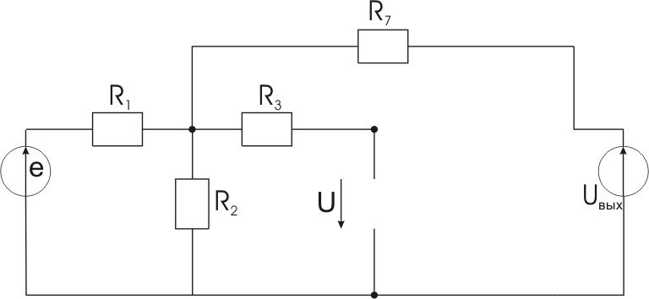
Установившийся режим: (С₁ и С₂ – обрыв).
$$e=1; U_{\text{вых}}=k_{0}U; h_{\text{уст}}=k_{0}U_{\text{уст}}|_{e}$$
$$U_{\text{уст}}|_{e}=\frac{e}{R_{1}+\frac{R_{2}R_{7}}{R_{2}+R_{7}}}⋅\frac{R_{7}R_{2}}{R_{2}+R_{7}}+\frac{U_{\text{вых}}}{R_{7}+\frac{R_{1}R_{2}}{R_{1}+R_{2}}}⋅\frac{R_{1}R_{2}}{R_{1}+R}=$$
$$=\frac{R_{2}R_{7}}{R_{1}R_{2}+R_{1}R_{7}+R_{2}R_{7}}+\frac{k_{0}U_{\text{уст}}R_{1}R_{2}}{R_{1}R_{2}+R_{1}R_{7}+R_{2}R_{7}}=0\text{.}1+0\text{.}4U_{\text{уст}}|_{e}$$
$$U_{\text{уст}}|_{e}(1−0\text{.}4)=0\text{.}1 ⇒ U_{\text{уст}}|_{e}={h_{\text{уст}}}/{k_{0}}=0\text{.}1/0\text{.}6=0\text{.}\text{1667} ⇒$$
$$\begin{aligned}h_{\text{уст}}=k_{0}⋅0\text{.}\text{1667}=1\text{.}\text{3333}⋅0\text{.}\text{1667}=0\text{.}\text{2222} \\ h(0)=k_{0}U(0)|_{e}=k_{0}U_{C2}(0)↑^{0}=0 ⇒ {\text{dh}}/{\text{dt}}(0) − \text{из} \text{уравнений} \text{состояния}: \\ \frac{\text{dh}}{\text{dt}}(0)=k_{0}\frac{{\text{dU}}_{C2}}{\text{dt}}(0)|_{e}=k_{0}\left[\frac{g_{3}}{C_{2}}U_{C1}(0)↑^{0}+\frac{−g_{3}(1−k_{0})}{C_{2}}U_{C1}(0)↑^{0}\right]=0 ⇒ \frac{\text{dh}}{\text{dt}}(0)=0 1/c\end{aligned}$$
Получаем:
$$\begin{aligned}h(0)=h_{\text{уст}}+A_{1}\text{sin}ϕ_{1}=0\text{.}\text{2222}+A_{1}\text{sin}ϕ_{1}=0 ⇒ A_{1}\text{sin}ϕ_{1}=−0\text{.}\text{2222} \\ \frac{\text{dh}}{\text{dt}}(0)=−{αA}_{1}\text{sin}ϕ_{1}+ω_{\text{св}}A_{1}\text{cos}ϕ_{1}=0 ⇒ A_{1}\text{cos}ϕ_{1}=\frac{α⋅A\text{sin}ϕ_{1}}{ω_{\text{св}}}\end{aligned}$$
$$\text{tg}ϕ_{1}=\frac{A_{1}\text{sin}ϕ_{1}}{A_{1}\text{cos}ϕ_{1}}=\frac{ω_{\text{св}}}{α}=2\text{.}\text{467}; ϕ_{1}=\text{67}\text{.}\text{49}°; A_{1}=\frac{−0\text{.}\text{2222}}{\text{sin}ϕ_{1}}=−0\text{.}\text{23976}$$
Получаем:
$$h(t)=0\text{.}\text{2222}−0\text{.}\text{23976}⋅e^{−0\text{.}\text{4483}⋅{\text{10}}^{4}⋅t}\text{sin}(1\text{.}\text{106}⋅{\text{10}}^{4}t+\text{67}\text{.}\text{94}°)$$
Найдем h_{δ}(t), h_{δ} = dh/dt.
$$\begin{aligned}h_{δ}(t)=0\text{.}\text{23976}⋅0\text{.}\text{4483}⋅{\text{10}}^{4}⋅e^{−0\text{.}\text{4483}⋅{\text{10}}^{4}⋅t}\text{sin}(1\text{.}\text{106}⋅{\text{10}}^{4}t+\text{67}\text{.}\text{94}°)− \\ −0\text{.}\text{23976}⋅1\text{.}\text{106}⋅{\text{10}}^{4}⋅e^{−0\text{.}\text{4483}⋅{\text{10}}^{4}⋅t}\text{cos}(1\text{.}\text{106}⋅{\text{10}}^{4}t+\text{67}\text{.}\text{94}°)= \\ =0\text{.}\text{107484}⋅{\text{10}}^{4}⋅e^{−0\text{.}\text{4483}⋅{\text{10}}^{4}⋅t}\text{sin}(1\text{.}\text{106}⋅{\text{10}}^{4}t+\text{67}\text{.}\text{94}°)− \\ −0\text{.}\text{23976}⋅1\text{.}\text{106}⋅{\text{10}}^{4}⋅e^{−0\text{.}\text{4483}⋅{\text{10}}^{4}⋅t}\text{cos}(1\text{.}\text{106}⋅{\text{10}}^{4}t+\text{67}\text{.}\text{94}°)= \\ =0\text{.}\text{28613}⋅{\text{10}}^{4}⋅e^{−0\text{.}\text{4483}⋅{\text{10}}^{4}⋅t}\text{sin}(1\text{.}\text{106}⋅{\text{10}}^{4}t) 1/c\end{aligned}$$

б) с помощью преобразований Лапласа.
Из п.1.1. $H(p)=\frac{0\text{.}\text{31646}⋅{\text{10}}^{8}}{1\text{.}\text{42406}⋅{\text{10}}^{8}+p⋅0\text{.}\text{89667}⋅{\text{10}}^{4}+p^{2}}$
При Е = 1, Е(р) = 1/p.
$$U_{\text{вых}}(p)=H(p)⋅E(p)=\frac{0\text{.}\text{31646}⋅{\text{10}}^{8}}{p⋅\left(1\text{.}\text{42406}⋅{\text{10}}^{8}+p⋅0\text{.}\text{89667}⋅{\text{10}}^{4}+p^{2}\right)}=\frac{F_{1}(p)}{p⋅F_{2}(p)}$$
Применяем терему разложения:
$$\begin{aligned}F_{2}(p)=0 ⇒ P=−0\text{.}\text{4483}⋅{\text{10}}^{4}±j1\text{.}\text{106}⋅{\text{10}}^{4} 1/c \\ F_{2}'(p)=2p+0\text{.}\text{89667}⋅{\text{10}}^{4}\end{aligned}$$
Находим оригинал:
$$\begin{aligned}h(t)=U_{\text{вых}}(t)|_{E=1}=\frac{F_{1}(0)}{F_{2}(0)}+2\text{Re}\left[\frac{F_{1}(p_{1})}{p_{1}F_{2}'(p_{1})}e^{p_{1}t}\right]=\frac{0\text{.}\text{31646}⋅\text{10}}{1\text{.}\text{42406}⋅{\text{10}}^{8}}+ \\ +2\text{Re}\left[\frac{0\text{.}\text{31646}⋅{\text{10}}^{4}⋅e^{−0\text{.}\text{4483}⋅{\text{10}}^{4}⋅t}⋅e^{j1\text{.}\text{106}⋅{\text{10}}^{4}⋅t}}{(−0\text{.}\text{4483}+j⋅1\text{.}\text{106})⋅{\text{10}}^{4}(2\left[−0\text{.}\text{4483}+j⋅1\text{.}\text{106}\right]⋅{\text{10}}^{4}+0\text{.}\text{89667}⋅{\text{10}}^{4})}\right]= \\ =0\text{.}\text{2222}+2\text{Re}\left[\frac{0\text{.}\text{31648}⋅{\text{10}}^{8}⋅e^{−0\text{.}\text{4483}⋅{\text{10}}^{4}⋅t}⋅e^{j1\text{.}\text{106}⋅{\text{10}}^{4}⋅t}}{−1\text{.}\text{1934}⋅{\text{10}}^{4}e^{−j\text{67}\text{.}\text{94}°}2⋅1\text{.}\text{106}⋅{\text{10}}^{4}e^{j\text{90}°}}\right]= \\ =0\text{.}\text{2222}−0\text{.}\text{23978}e^{−0\text{.}\text{4483}⋅{\text{10}}^{4}⋅t}\text{cos}(1\text{.}\text{106}⋅{\text{10}}^{4}t+\text{67}\text{.}\text{94}°−\text{90}°)= \\ =0\text{.}\text{2222}−0\text{.}\text{23978}e^{−0\text{.}\text{4483}⋅{\text{10}}^{4}⋅t}\text{sin}(1\text{.}\text{106}⋅{\text{10}}^{4}t+\text{67}\text{.}\text{94}°)\end{aligned}$$
Т.к. h_{δ}(t) = dh/dt ⇒ $\frac{\text{dh}}{\text{dt}}=^{}{\text{pU}}_{\text{вых}}(p)=p⋅\frac{1}{p}⋅H(p)=H(p)$
$$H(p)=\frac{0\text{.}\text{31646}⋅{\text{10}}^{8}}{p⋅\left(1\text{.}\text{42406}⋅{\text{10}}^{8}+p⋅0\text{.}\text{89667}⋅{\text{10}}^{4}+p^{2}\right)}=\frac{F_{1}(p)}{F_{2}(p)}$$
Находим оригинал:
$$\begin{aligned}h_{δ}(t)=2\text{Re}\left[\frac{F_{1}(p_{1})}{F_{2}'(p1)}e^{p_{1}t}\right]=2\text{Re}\left[\frac{0\text{.}\text{31646}⋅{\text{10}}^{8}e^{−0\text{.}\text{483}⋅{\text{10}}^{4}⋅t}e^{j1\text{.}\text{106}⋅{\text{10}}^{4}⋅t}}{2(−0\text{.}\text{4483}+j1\text{.}\text{106}){\text{10}}^{4}+0\text{.}\text{89667}⋅{\text{10}}^{4}}\right]= \\ =0\text{.}\text{28613}⋅{\text{10}}^{4}⋅e^{−0\text{.}\text{483}⋅{\text{10}}^{4}⋅t}\text{cos}(1\text{.}\text{106}⋅{\text{10}}^{4}t−\text{90}°)=0\text{.}\text{28613}⋅{\text{10}}^{4}e^{−0\text{.}\text{483}⋅{\text{10}}^{4}⋅t}\text{sin}(1\text{.}\text{106}⋅{\text{10}}^{4}t) 1/c\end{aligned}$$

2.2. Расчет характеристики h(t).
$$h(t)=0\text{.}\text{2222}−0\text{.}\text{23978}e^{−0\text{.}\text{4483}⋅{\text{10}}^{4}⋅t}\text{sin}(1\text{.}\text{106}⋅{\text{10}}^{4}t+1\text{.}\text{186} \text{рад})$$
$$T_{\text{св}}=\frac{2π}{ω_{{\text{св}}^{2}}}=\frac{2π}{1\text{.}\text{106}⋅{\text{10}}^{4}}=5\text{.}\text{681}⋅{\text{10}}^{−4} c$$
Интервал [0; 2T_{cв}] = [0; 11.410⁻⁴ c]
t, 10⁻⁴ c | 0 | 2 | 4 | 6 | 8 | 10 | 11,4
h | 0 | 0,247 | 0,247 | 0,206 | 0,226 | 0,223 | 0,221

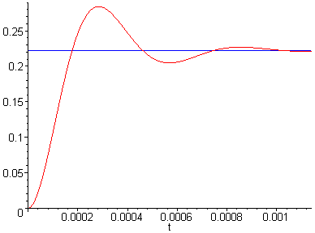
t_{и} = 4.609⋅10⁻⁴ c.
h(t_{и}) = 0.2222

2.4. Форма выходного сигнала при воздействии на вход переменного импульса.
Е₀ = 1 В. U_{вх}(0) = Е₀
t_{и} = 4.609⋅10⁻⁴ c. U_{вх}(t_{и-}) = Е₀
U_{вх}’ = dU_{вх}/dt = 0 U_{вх}(t_{и+}) = 0
При t_{и} = 4.609⋅10⁻⁴ c.

a) 0 ≤ t ≤ t_{и}
$$\begin{aligned}U_{\text{вх}}=U_{\text{вх}}(0)h(t)+\int_{0}^{t}{U_{\text{bx}}'(x)h(t−x)\text{dx}}=E_{0}h(t)=1h(t)= \\ 0\text{.}\text{2222}−0\text{.}\text{23976}e^{−0\text{.}\text{4483}⋅{\text{10}}^{4}t}\text{sin}(1\text{.}\text{106}⋅{\text{10}}^{4}t+1\text{.}\text{186} \text{рад}) (B)\end{aligned}$$
б) t_{и} ≤ t ≤ ∞
$$\begin{aligned}U_{\text{bx}}=U_{\text{bx}}(0)h(t)+\int_{0}^{\text{tu}}{U_{\text{bx}}'(x)h(t−x)\text{dx}+\left[U_{\text{bx}}(t_{u+})−U_{\text{bx}}(t_{u−})\right]h(t−t_{u})}=E_{0}h(t)−E_{0}h(t−t_{u})= \\ 1h(t)−1h(t−t_{u})=−0\text{.}\text{23976}e^{−0\text{.}\text{4483}⋅{\text{10}}^{4}t}\text{sin}(1\text{.}\text{106}⋅{\text{10}}^{4}t+1\text{.}\text{186} \text{рад})+ \\ +0\text{.}\text{23976}e^{−0\text{.}\text{4483}⋅{\text{10}}^{4}(t−t_{u})}\text{sin}(1\text{.}\text{106}⋅{\text{10}}^{4}(t−t_{u})+1\text{.}\text{186} \text{рад})= \\ −0\text{.}\text{23976}e^{−0\text{.}\text{4483}⋅{\text{10}}^{4}t}\text{sin}(1\text{.}\text{106}⋅{\text{10}}^{4}t+1\text{.}\text{186} \text{рад})− \\ −e^{−0\text{.}\text{4483}⋅{\text{10}}^{4}⋅4\text{.}\text{609}⋅{\text{10}}^{−4}}\text{sin}(1\text{.}\text{106}⋅{\text{10}}^{4}t−1\text{.}\text{106}⋅{\text{10}}^{4}4\text{.}\text{609}⋅{\text{10}}^{−4}+1\text{.}\text{186} \text{рад})= \\ −0\text{.}\text{23976}e^{−0\text{.}\text{4483}⋅{\text{10}}^{4}t}\left[\text{sin}(1\text{.}\text{106}⋅{\text{10}}^{4}t+1\text{.}\text{186} \text{рад})−7\text{.}\text{8949}\text{sin}(1\text{.}\text{106}⋅{\text{10}}^{4}t−3\text{.}\text{9116} \text{рад})\right] (B)\end{aligned}$$
Зависимость U_{bx}(t).
t, 10⁻⁴ c | 0 | 2 | 4 | 4.609 | 6 | 8 | 10 | 11.4
U_{bx}, B | 0 | 0.247 | 0.247 | 0.2222 | 0.0358 | -0.047 | 0.017 | 0.006
